**Zonions Project Flow Structure**

1. Home component:

It is initial page of project. On that, page active restaurant list is displayed that means which restaurants are currently available for service.

Naming Convention for Home page:

[home.component.html](http://home.component.html) contains html code of home page.

[Home.component.ts](http://Home.component.ts) contains view logic behind [home.component.html](http://home.component.html)

When click on Active restaurant it navigates to restaurant detail.

View:

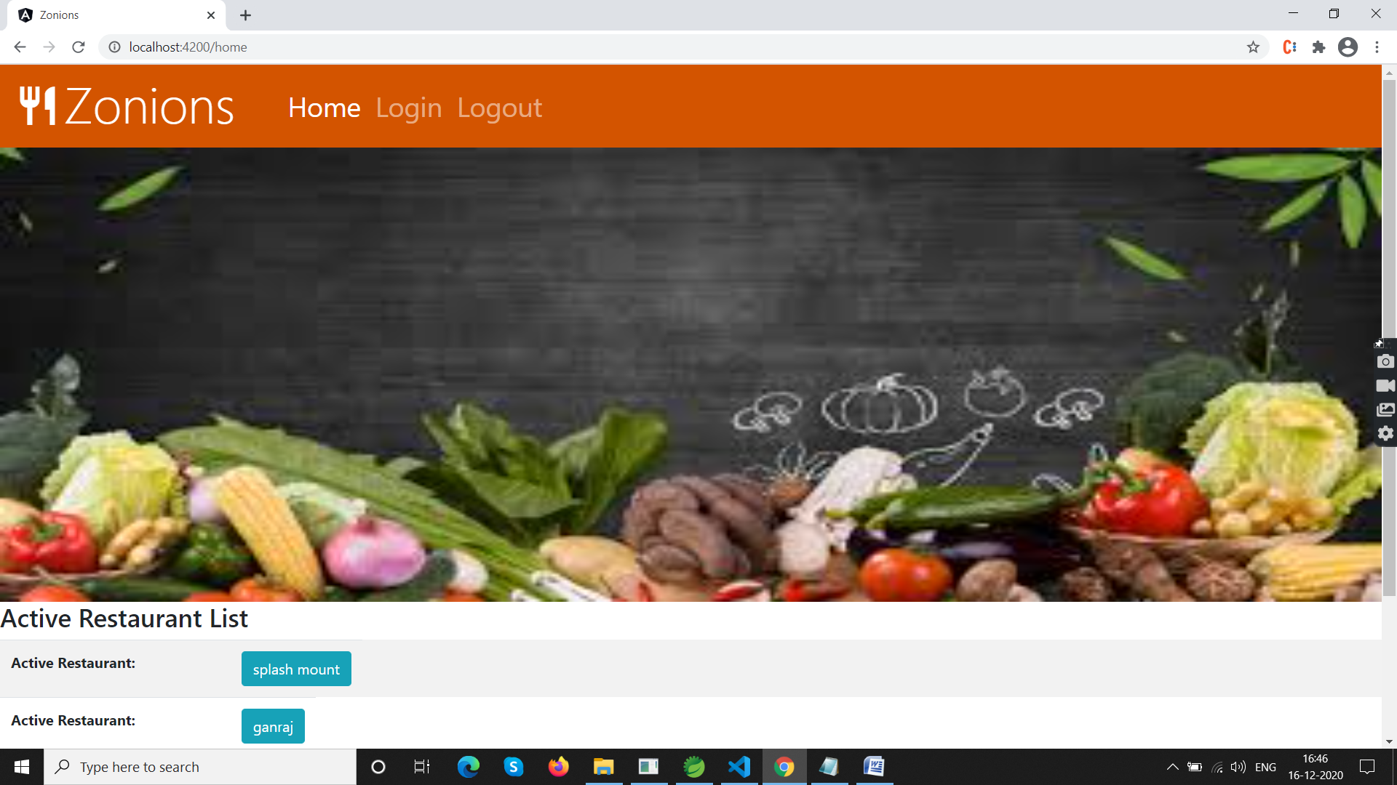

1. Restaurant details page

Restaurant details page displays active restaurant details.

Naming Convention:

restaurant-details.component.html- contains view

restaurant-details.component.ts- view logic behind view page

View:

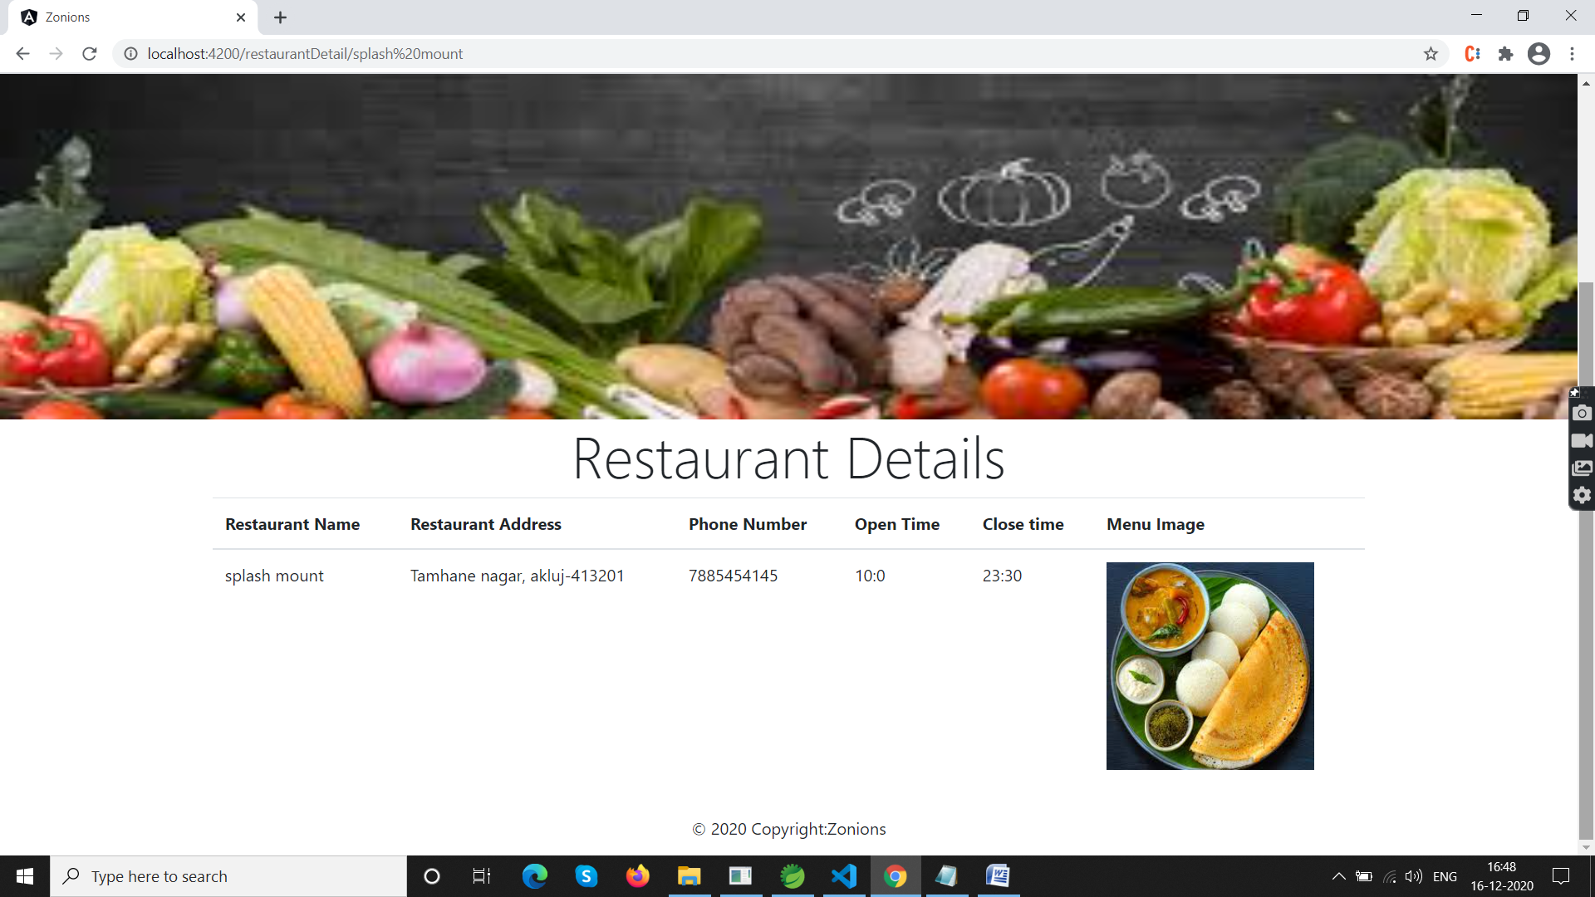

1. Login:

Login component authenticates user.

After inserting correct username and password it navigates to admin page.

Naming convention:-

login.component.html

login.component.ts

View:

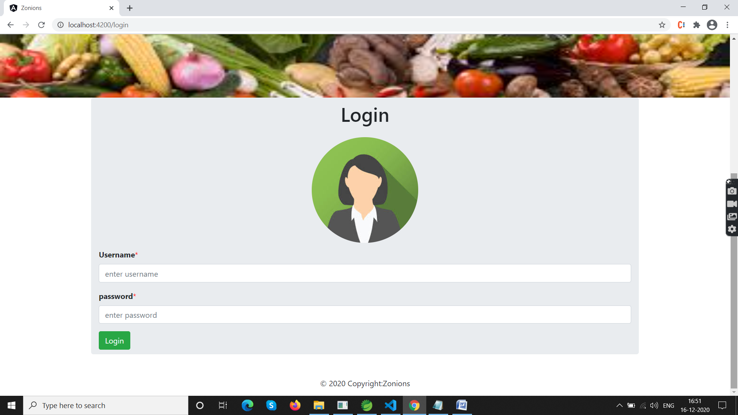

1. Admin:

Admin page contains two buttons

Restaurant list and Restaurant.

Onclick on restaurant List navigates to restaurant list.

Onclick on restaurant it navigates to add restaurant page.

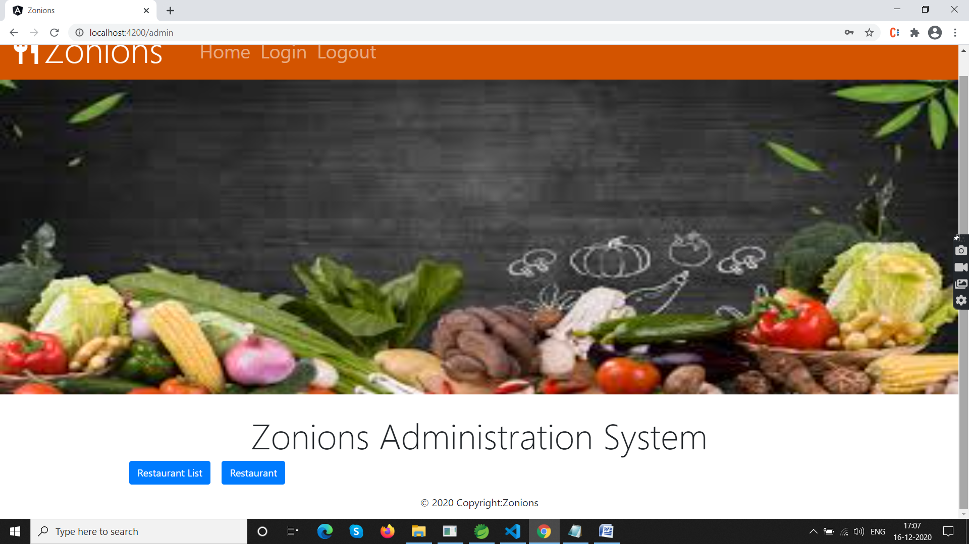

1. Restaurant List:-

It displays all restaurant available in the system. It contains Edit, Delete and Change status functionality.

Edit allows to admin user to edit the restaurant details.

Delete allows to admin user to delete restaurant.

Change status allows user to change status active to deactive and deactive to active.

View:

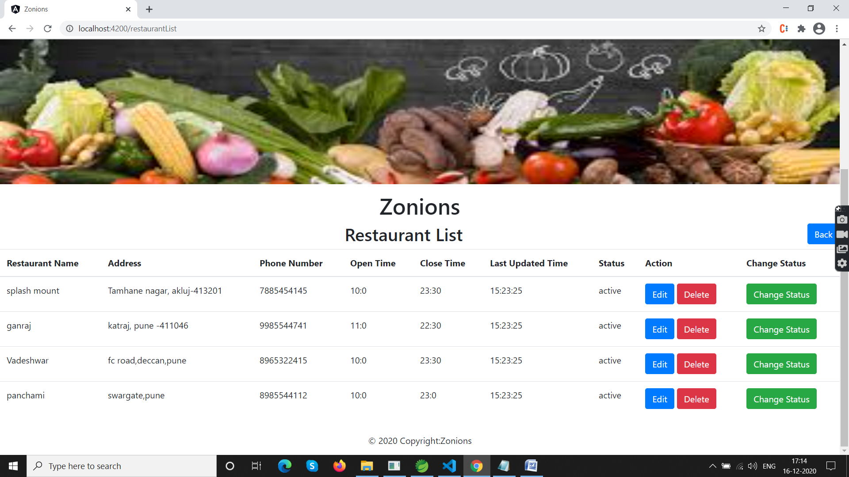

Update:

It Edit restaurant details.

View:

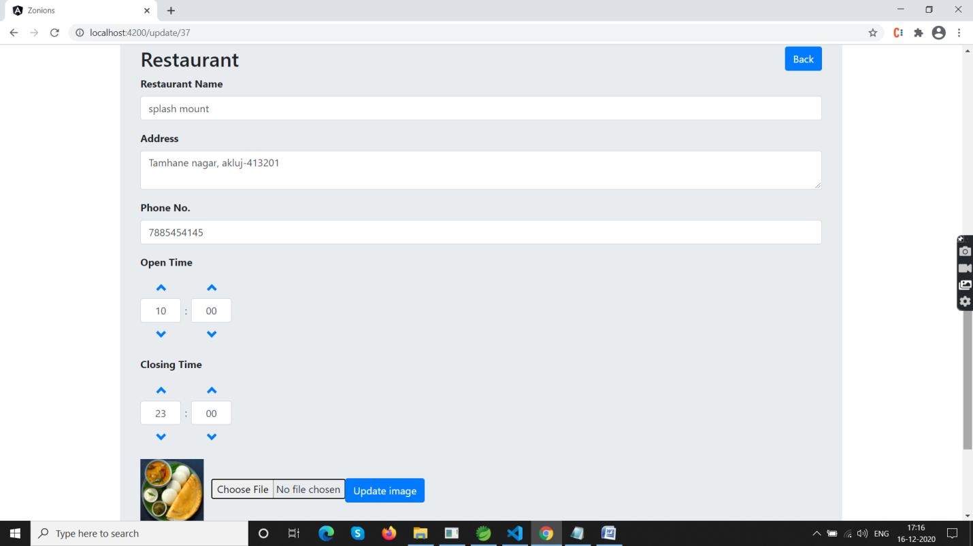

1. Add Restaurant:

It adds new restaurant details . After adding Restaurant it navigates to restaurant list page.

View:-

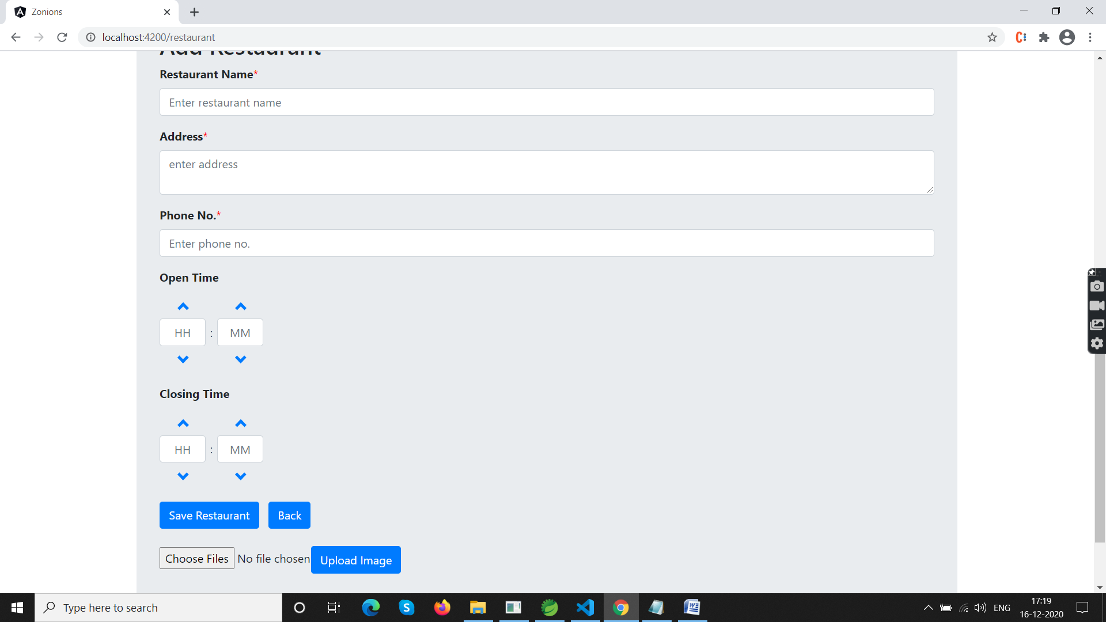

**Improve Areas:**

Work on css and UI part to make UI effective.